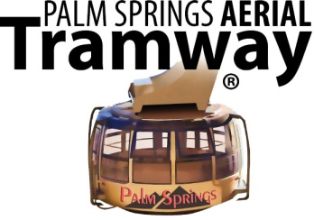

FOR IMMEDIATE RELEASE
Contact: Greg Purdy
VP Marketing & Public Affairs
1 Tram Way
Palm Springs, CA 92262
(760) 969-4356
Email: gpurdy@pstramway.com

CELEBRATE VALENTINE’S DAY IN AN ALPINE FOREST
Peak’s Restaurant Offers Special Prix Fixe Menu

PALM SPRINGS, CA (January 28, 2018) Peak’s Restaurant—at the top of the Palm Springs Aerial Tramway—will offer a special 3-course prix fixe menu on Valentine’s Day for $60.00. The menu includes choice of appetizer (carrot ginger soup or Mandarin salad), entrée (braised short ribs, seared ahi or Primavera) and trio of desserts, plus a glass of champagne.

The prix fixe menu—in addition to Peak’s regular menu— will be served on February 14 from 11:00 a.m. to 4:00 p.m. and from 5:00 p.m. to 8:00 p.m. Reservations are recommended. Tax, gratuity and tram admission are not included.

Already have plans for lunch or dinner? Discover another side of romance and spend the day in the Mount San Jacinto State Park or just enjoy the views from the Mountain Station view terraces.

Tram admission is $25.95 for adults and $16.95 for children ages 3-10 years. Special discounts and packages are available after 4:00 p.m. — Twilight Tickets are $22.95 for adults and seniors, and $13.95 for children ages 3-10. Ride ‘n’ Dine tickets are $36 for adults and seniors, and $23.50 for children ages 3-10. This combination ticket includes Tram admission and dinner at Pines Café.

****

About Palm Springs Aerial Tramway
The Palm Springs Aerial Tramway is the world’s largest rotating tram car. Opened in 1963, the Tram’s 80-passenger cars travel along the breathtaking cliffs of Chino Canyon from the Valley Station (elevation 2,643 ft.) to the Mountain Station (elevation 8,516 ft.) in approximately 10 minutes. For more information, please call 888.515.TRAM or 760.325.1391, or visit us at www.pstramway.com.
______________________________________________________
NOTE TO EDITORS: For additional information, high-resolution Tramway images or HD B-roll, please contact Greg Purdy at (760) 969-4356, email gpurdy@pstramway.com or visit www.pstramway.com/media.

